|  |  |  |  |
| --- | --- | --- | --- |
| **PROJECT** |  | **JOB No** |  |
| **AREA** |  | **DRG No** |  |

|  |  |
| --- | --- |
| **Inspection Checklist Details** | |
| **Item** | **Description** |
| **1** | Check that the extinguisher is conspicuous, readily accessible and in its assigned location in accordance with the approved plan. |
| **2** | Check that the extinguisher is mounted at the appropriate height in accordance with Figure 3.2. |
| **3** | Check that the anti-tamper device is intact. And that the service tag or label is firmly attached. |
| **4** | Check that the extinguisher is clean and the operating instructions are legible. |
| **5** | Check that the extinguisher, including any attachments, is not damaged. |
| **6** | Check that the hose is securely fitted, the nozzle is securely attached, the assembly is free from obstruction, and the hose shows no cracking or other signs of damage or deterioration. |
| **7** | Check that the appropriate discharge nozzle is fitted and is not blocked or damaged. |
| **8** | Where fitted, check that the pressure indicator is legible, and registering within the operable range. |
| **9** | Check that the appropriate support bracket is securely attached to wall or other suitable feature. |

|  |  |  |  |  |  |  |  |  |  |  |  |  |  |  |  |  |  |  |  |  |  |  |
| --- | --- | --- | --- | --- | --- | --- | --- | --- | --- | --- | --- | --- | --- | --- | --- | --- | --- | --- | --- | --- | --- | --- |
| **Fire Extinguisher Details** | | **Installation Inspection Checklist** | | | | | | | | | | | | | | | | | | | | |
| Item 1 | | Item 2 | | Item 3 | | Item 4 | | Item 5 | | Item 6 | | Item 7 | | Item 8 | | Item 9 | | Item 10 | |
| **. No.** | **Location** | Yes | No | Yes | No | Yes | No | Yes | No | Yes | No | Yes | No | Yes | No | Yes | No | Yes | No | Yes | No |
|  |  |  |  |  |  |  |  |  |  |  |  |  |  |  |  |  |  |  |  |  |  |
|  |  |  |  |  |  |  |  |  |  |  |  |  |  |  |  |  |  |  |  |  |  |
|  |  |  |  |  |  |  |  |  |  |  |  |  |  |  |  |  |  |  |  |  |  |
|  |  |  |  |  |  |  |  |  |  |  |  |  |  |  |  |  |  |  |  |  |  |
|  |  |  |  |  |  |  |  |  |  |  |  |  |  |  |  |  |  |  |  |  |  |
|  |  |  |  |  |  |  |  |  |  |  |  |  |  |  |  |  |  |  |  |  |  |
|  |  |  |  |  |  |  |  |  |  |  |  |  |  |  |  |  |  |  |  |  |  |
|  |  |  |  |  |  |  |  |  |  |  |  |  |  |  |  |  |  |  |  |  |  |
|  |  |  |  |  |  |  |  |  |  |  |  |  |  |  |  |  |  |  |  |  |  |
|  |  |  |  |  |  |  |  |  |  |  |  |  |  |  |  |  |  |  |  |  |  |
|  |  |  |  |  |  |  |  |  |  |  |  |  |  |  |  |  |  |  |  |  |  |
|  |  |  |  |  |  |  |  |  |  |  |  |  |  |  |  |  |  |  |  |  |  |

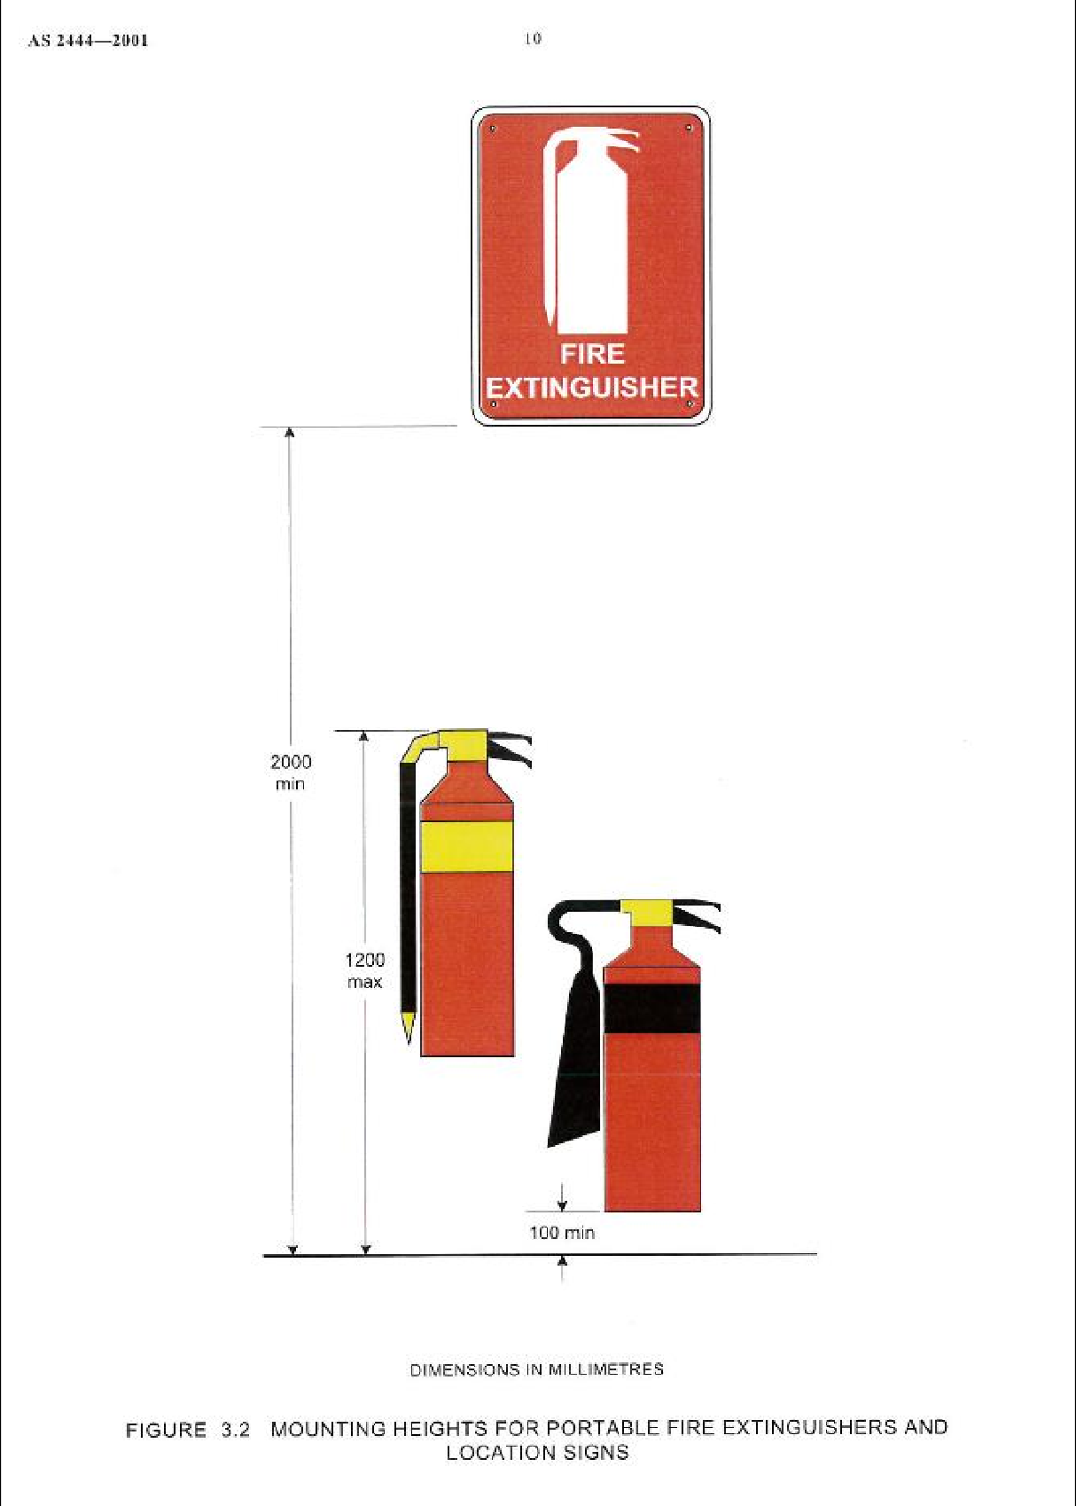

|  |  |  |  |  |  |
| --- | --- | --- | --- | --- | --- |
| **Checked By;**  **(Leemark)** | **Signature;** | | | **Date;** | |
|  |  |  |  |  |  |
| **Checked By;**  **(Builder)** | **Signature;** | | | **Date;** | |